**QUESTION 1)**

3.1) Performance measures

Let {$Q_{1}$, …, $Q_{q}$} be the set of query images. For the i-th query $Q_{b}$ let $I_{1}^{(i)}$,…, $I_{a_{1}}^{(i)}$ are correct answers and rank($I_{j}^{(i)}$) is the rank of $I_{j}^{(i)}$ in the result. We use three performance measures [7] :

1. Avg-r = $\frac{1}{q}\sum_{i=1}^{q}{\frac{1}{a_{i}}}\sum_{j=1}^{a_{i}}{rank(I_{j}^{(i)})}$.
2. Avg-p = $\frac{1}{q}\sum_{i=1}^{q}{\frac{1}{a_{i}}}\sum_{j=1}^{a_{1}}{\frac{j}{rank(I_{j}^{(i)})}}$.
3. Recall vs. Scope. For query $Q_{i}$ and scope S(S>0) :

Recall r = | { | rank($I_{j}^{(i)}$) ≤ S } / $a_{i}$.

**QUESTION 2)**

***Challenges:***

***Physical*** : Saena primarily faces the physical challenges; as traveling merchant’s daughter, she has learned to fight; she faces the Dark Fae but suffers weakness in her mental defenses against their magic; Aerim learns to fight from Saena and helps her learn to defend herself mentally.

***Magical:*** Aerim is surprisingly resilient to magic and discovers his growing powers as he and Saena venture into the Forest to investigate their foe and find the root to the decay of the land; he must ultimately confront the truth that his mother was a Dark Fae and was responsible for introducing sickness to the human race.

**QUESTION 3)**

M

illions of people are already suffering from the catastrophic effects of extreme disasters exacerbated by climate change – from prolonged drought in sub-Saharan Africa to devastating tropical storms sweeping across Southeast Asia, the Caribbean and the Pacific. During the summer months for the northern hemisphere in 2018, communities from the Arctic Circle to Greece, Japan, Pakistan (on 22 May 2018 temperature reached as high as 44 degrees creating around 65 casualties ) and the USA experienced devastating heatwaves and wildfires that resulted in the deaths of hundreds of people.

While we largely understand climate change through the impacts it will have on our natural world, it is the devastation that it is causing and will continue to cause for humanity that makes it an urgent human rights issue. It will compound and magnify existing inequalities. And its effects will continue to grow and worsen over time, creating ruin for current and future generations. This is why the failure of governments to act on climate change in the face of overwhelming scientific evidence may well be the biggest inter-generational human rights violation in history.

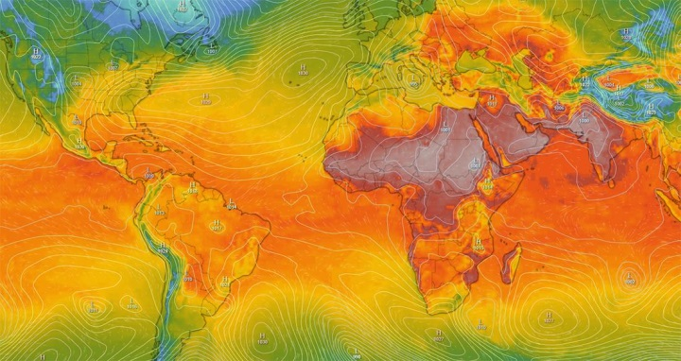 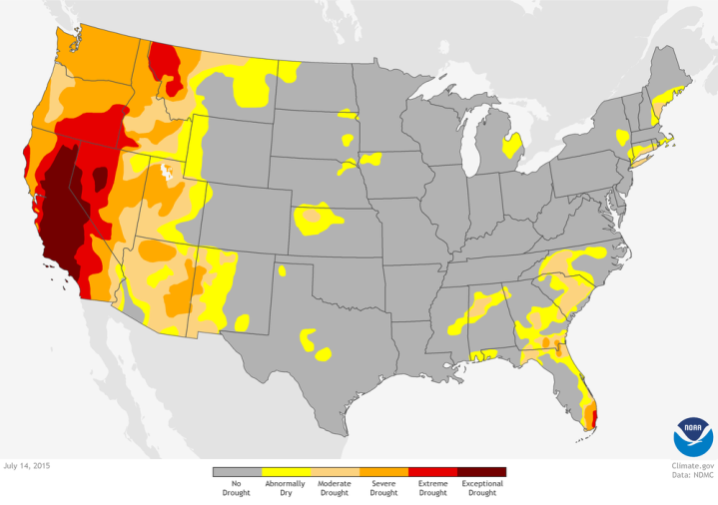

The planet's climate has constantly been changing over geological time, with significant fluctuations of global average temperatures.

However, this current period of warming is occurring more rapidly than any past events. It has become clear that humanity has caused most of the last century’s warming by releasing heat-trapping gases—commonly referred to as greenhouse gases—to power our modern lives. We are doing this through burning fossil fuels, agriculture and land-use and other activities that drive climate change. Greenhouse gases are at the highest levels they have ever been over the last 800,000 years. This rapid rise is a problem because it’s changing our climate at a rate that is too fast for living things to adapt to.

Climate change involves not only rising temperatures, but also extreme weather events, rising sea levels, shifting wildlife populations and habitats, and a range of other impacts.

Reference:

(Climate change, 2020)

QUESTION 4)

**SALES TABLE**

|  |  |  |  |  |  |  |
| --- | --- | --- | --- | --- | --- | --- |
| Region | District | Store  Name | Employee  Name | Customer  Count | Cost | Sale |
| ± Ali | Total |  |  | 153 | 9724 | 13149 |
|  | ±Ahmed | Total |  | 153 | 9724 | 13149 |
|  | ±Imtiaz |  |  |  |  |
|  | Ayaz | 53 | 611 | 830 |
| Wajahat | 40 | 731 | 1429 |
| Maaz | 60 | 8382 | 10890 |
| Total |  |  |  | 153 | 9724 | 10890 |

QUESTION 5)

**The pandemic we are facing today is turning the world upside down. Influencing all spheres of action, from business, to arts, to international development. Influencing the way we interact, the way we work, the way we live. As we confront this unprecedented pandemic, the world has come to the realization that** **handwashing with water and soap is one of the best preventative measures when it comes to saving lives. Much of the world’s populations do not have access to water, soap, or even toilets. Less than half of health care facilities in the least developed countries lack basic water services[1]. This not only puts patients and health care providers at risk of contracting COVID-19 but also extends to entire communities**.

*Providing* *vulnerable communities what it takes for proper hygiene is vital. Literally. But we cannot tackle this challenge by simply digging wells and building handwashing stations or toilets. To make sure health practitioners and patients all over the world are empowered to do what is necessary to prevent contagion, we must be united in promoting a behavioral shift as well. And we must remain open to creative solutions, especially those that are proven to work, and that are endorsed by leading organizations such as the United Nations and the* *World Health Organization.*

Today, with coronavirus rapidly spreading into low to middle-income countries, we can all agree that the momentum is stronger than ever and that it is time to take action, together. Lately, we have seen 1.3 billion people in India[2] —one fifth of the global population—being ordered to stay inside. The situation in the country was already critical, as 42 per cent of its health care facilities do not have hand hygiene facilities[3]. Imagine the unprecedented spread of the virus in a population that is already vulnerable. And what about sub-Saharan Africa, where four out of ten people cannot wash their hands at home[4] ? We need to increase our actions in these areas[5].

QUESTION 6)

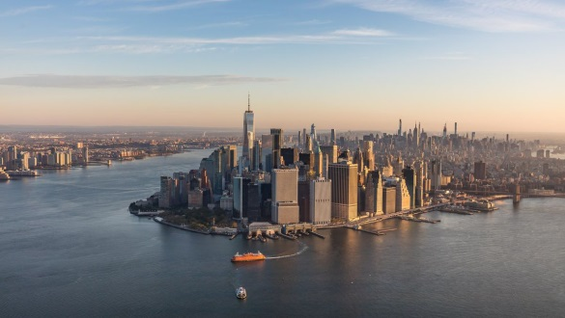San Francisco is the financial, cultural, and transportation center of the San Francisco Bay area, a region of 7.15 million people which includes San Jose and Oakland. The only consolidated city-county in California, it encompasses a land area of about 121 ${Km}^{2}$ on the northern end of the San Francisco peninsula, giving it a density of about 6,632 people per ${Km}^{2}$. It is the most densely settled large city (population greater than 200,000) in the state of California and the second-most densely populated large city in the United States after New York City. Today, San Francisco is one of the top tourist destinations in the world, ranking 33rd out of 100 most visited cities worldwide, and is renowned for its chilly summer fog, steep rolling hills, eclectic mix of architecture, and its famous landmarks, including the **Golden Gate Bridge,** cable cars, and Chinatown. The city is also a principal banking and finance center, and the home to more than 30 International financial institutions, helping to make San Francisco rank eighteenth in the world’s top producing cities, ninth in the United States, and thirteenth place in the top twenty global financial centers.

1. WASH in health care facilities : Global Baseline Report 2019
2. New York Time , May 24 2020
3. Joint Monitoring Program 2019
4. Joint Monitoring Program 2017
5. The need to protect populations all over the world is clearer than ever , and we must be proactive in reflecting on what must come next

   BOOKMARKS:

   1 ) HANDWASHING

   2 ) VULNERABLE

   3) WHO (World Health Organization)

   4 ) UN (United Nation)

   # PAKISTAN

  